

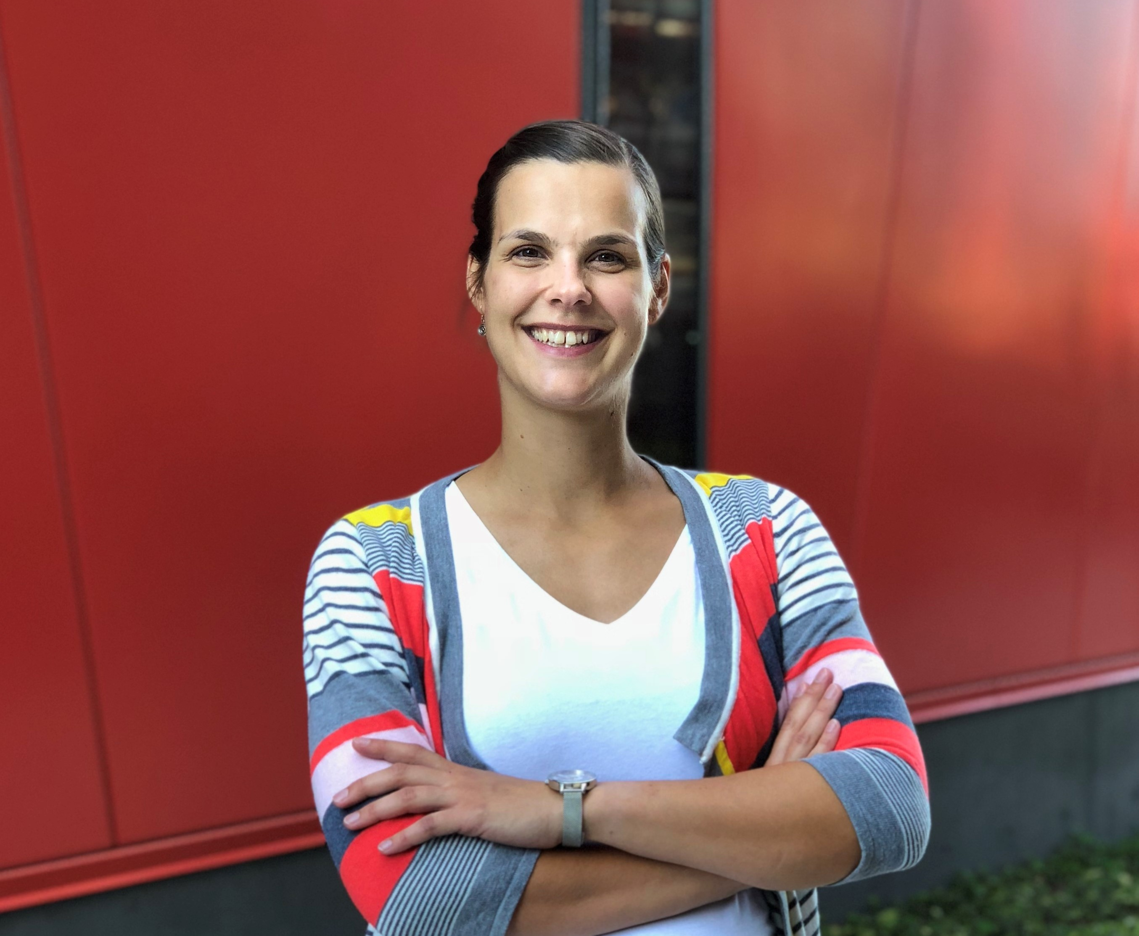

External Seminar

Julia Ritterhoff, Ph.D.
University of Washington
Department of Anesthesiology and Pain Medicine
Mitochondria and Metabolism Center – Tian Lab

Place: Analysezentrum 3, 2. OG, Room 02.332
Date: Monday, March 2nd
Time: 12.00 am

Taking sugar and fat to heart – How metabolic rewiring drives cardiac growth

Host: Prof. Dr. med. Johannes Backs
Director of the Institute of Experimental Cardiology
University of Heidelberg

